System Requirements Engineering

Assignment 1

CIT Weight Watchers Application

Date: October 5th 2017

Team Manager: Sinead Coughlan

Team Members: James Broaderick

Dean Healy

Megan McCarthy

Table of Contents:

1. Personas
   * 1. Shane O’Connell
     2. Shantelle mbamba
     3. Donald Obama
     4. Aaron Ramblin
2. User Scenarios
   * 1. Scenario 1
     2. Scenario 2
     3. Scenario 3
     4. Scenario 4
     5. Scenario 5
     6. Scenario 6
     7. Scenario 7
     8. Scenario 8

Personas:

Shane O’Connell

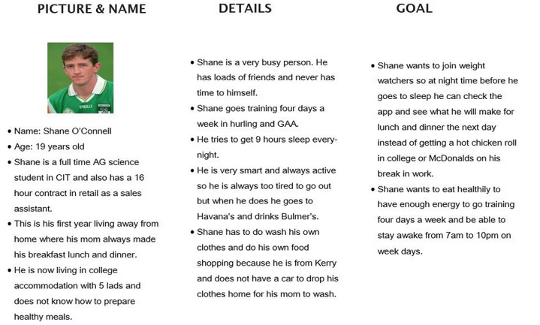

Shantelle Mbamba

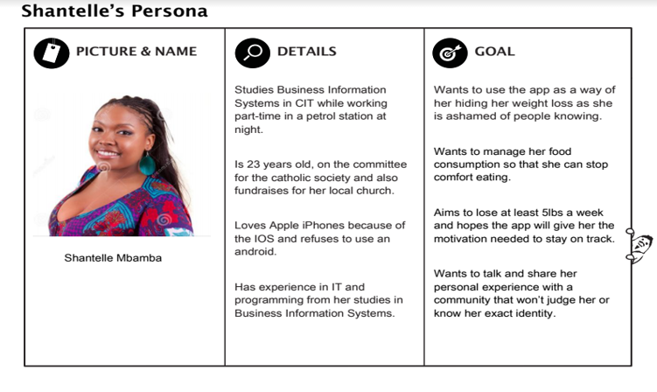

Donald Obama

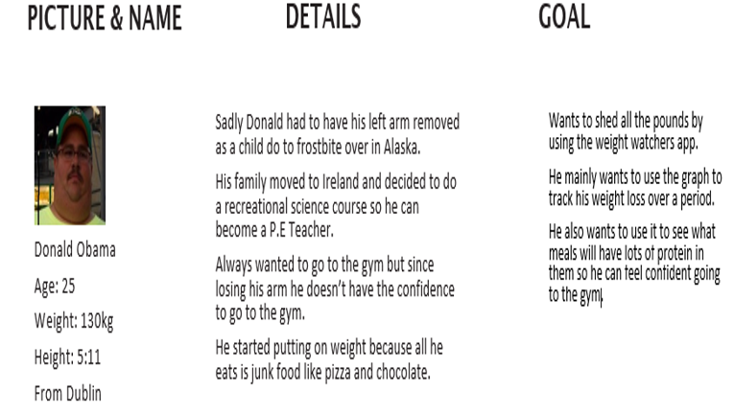

Aaron Ramblin

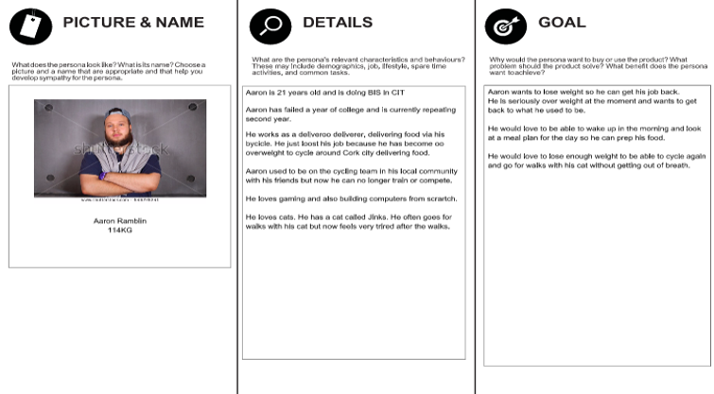

User Scenarios:

Scenario 1:

1. Shane doesn't know what to have for dinner.
2. Shane decides that he does not want anything unhealthy for dinner so he opens the Weight watchers app.
3. Shane is asked to enter his mycit email as his username and his mycit password as his password.
4. After shane logs in he selects the diet option.
5. Shane looks at what he has in his fridge and choses a recipe with the things that he has available.
6. Shane calls his mom to find out how to cook chicken safely.
7. Shane screenshots the recipe and logs out of the app.

Scenario 2:

1. Shane feels as though he has gained some weight over freshers weeks so he decides to log into his weight watchers app.
2. Shane is asked to enter his mycit email as his username and his mycit password as his password.
3. After shane has logged in successfully he chooses the weight trends options.
4. Shane decides to weigh himself to see if he is up or down weight from the last time he logged on.
5. Shane sees that in one week he has gained 1.9kgs from eating bad foods and not going training.
6. Shane enters his new weight into the app and the graph changes accordingly by reading shane’s old weight and his current weight and finding the difference between the two.
7. Shane decided to get his gear and go training so he logs off the app.

Scenario 3:

1. Shantelle sits at her table during lunch time and opens the CIT weight watcher app on her phone
2. Shantelle proceeds to login by providing her mycit email address and password
3. Shantelle scans the homepage of the app and clicks onto the “Diet” tab
4. Shantelle then uses the drop-down menu to look at her diet information for yesterday
5. Shantelle reads the page before exiting the app.

Scenario 4:

1. Shantelle opens the CIT weight watcher app on her phone while eating her dinner
2. Shantelle proceeds to login by providing her mycit email address and password
3. Shantelle scans the homepage of the app and clicks on the “Diet” tab
4. Shantelle lands on the page for today’s dietary information
5. Shantelle has already entered the information for the food she consumed at breakfast and lunch and now wants to add the information from her dinner
6. Shantelle clicks on the textbox in the dinner section
7. Shantelle then enters the food that she ate for her dinner and the application adds the calories to the total count.
8. Shantelle looks at her new total before closing the app.

Scenario 5:

1. Late Friday evening, and Donald just got home from CIT.
2. He wants to use the CIT Weight watchers application to see what exercises he can do for 30 minutes.
3. He opens the app on his phone and goes to the log in page.
4. He puts in his CIT email and password.
5. The app brings him to the home page where it shows his picture, his name, his current weight and starting weight when he first started using the app.
6. Donald then press the exercise button.
7. On the exercise page it had four different option Running, Swimming, Yoga or Dancing.
8. Donald presses the running button which then shows him how many calories he will lose in an hour, 30 minutes and 15 minute.
9. Donald decides to do the 30 minute running exercise.
10. Once done he goes back to the home screen and logouts.
11. Donald then closes the application.

Scenario 6:

1. It’s Sunday and Donald is looking to treat himself with a snack after a hard week of exercise and dieting
2. First he wants to check home much weight he lost over the course of the week.
3. He opens up the CIT weight watcher app.
4. He logins in using his CIT email and password.
5. At the home screen he clicks on weight trends to see a graph of his weight loss over the week.
6. After pressing the button the app seems to freeze.
7. He decides to wait and see if it will work after a few minutes but he application closes itself.
8. Donald tries the application again and is greeted with a send feedback box on what happened.
9. He fills out the box describing what happened while trying to use the application.
10. Then he presses send and an alert box comes up saying thanks for sending your feedback and the problem will be fixed shortly.
11. Donald closes the application and decides to try it again tomorrow.

Scenario 7:

1. Aaron wakes up in the morning hungry.

2. Aaron goes to the fridge but doesn’t know what to make

3. Aaron decides to open up the weight watchers app

4. He then decides what he is going to make

5. He wonders to himself what his bmi is

6. He opens the section where you can check your bmi

7. He types in his weight and his height and figures it out.

Scenario 8:

1. Aaron attends a weight watchers class

2. He is asked what his BMI is

3. He checks his BMI which he has been updating all the time

4. He weighs himself and realized he has lost weight

5. He then updates his bmi page again

6. He tells his weight watcher instructor what his BMI is

7. He is delighted with his result